Deliverable 3 – Autonomous Flight Record

2012 UAV Outback Challenge – Search and Rescue Challenge



[www.canberrauav.com](http://www.canberrauav.com)

Proudly Sponsored by:





Paul Tridgell

Terry Porter

Grant Morphett

Ron Graham

# Table of Contents

1 Table of Contents 2

2 Flight Logs 3

2.1 Flight Log Book 3

2.2 GPS Telemetry 5

2.3 Video 5

2.4 Static Images 5

3 RF Transmitters 10

3.1 2.4 GHz RC Link 10

3.2 900 MHz Telemetry Link 10

3.3 5.8 GHz Image and Telemetry Link 10

4 Aircraft Specifications and Performance 11

# Flight Logs

## Flight Log Book

The following is an extract from our flight log book.

| Date | Aircraft | Start  Time | Flight  Time | AUTO  time | Flight Comments | Bottle Drop? | Camera capturing? |
| --- | --- | --- | --- | --- | --- | --- | --- |
| 06/01/12 | Mugin | 1030 | 4:52 | 0:00 | Recording flight characteristics in order to tune autopilot. | Not fitted | Not fitted |
| 05/02/12 | Mugin | 1039 | 8:14 | 0:00 | Tuning of the autopilot’s stabilisation parameters. | Not fitted | Not fitted |
| 22/04/12 | Mugin | 1114 | 10:00 | 0:00 | Testing telemetry streams and bottle drop mechanism. Also capturing video for Deliverable 2 | Bottle released. Parachute did not open | Not fitted |
| 01/07/12 | Mugin | 1105 | 38:18 | 35:40 | Failsafe module (V1) test OK. Rough landing – slight nosewheel damage needs fixing. Dead stick landing – Suspect engine tuning problem. Excellent waypoint tracking. | Not fitted | Not running |
| 07/07/12 | Mugin | 1114 | 44:18 | 41:03 | Onboard computer crashed during flight. Motor stopped during flight. Dead stick landing. Some damage to nosecone | Not fitted | 16700 images captured. Joe successfully found by shirt colour |
| 07/07/12 | Mugin | 1342 | 36:47 | 34:51 | Motor stopped during flight. Dead stick landing. | Not fitted | 23320 images captured. Joe found by shirt colour |
| 15/07/12 | Mugin | 1301 | 36:05 | 34:40 | Very high winds. Mugin coped exceptionally well. 5.8 GHz radio link unreliable, possibly due to depleted avionics battery. | Not fitted | 9069 images captured. Joe found by shirt colour |
| 15/07/12 | Mugin | 1433 | 19:00 | 12:07 | Testing fuel system – only filled tank to 1/3 to determine fuel cut-out problem. Engine cut-out. Dead stick landing. HSV image filter tested. | Not fitted | No images captured |
| 21/07/12 | Mugin | 1239 | 68:49 | 62:11 | New header tank fitted. Airspeed sensor more accurate. Main wheel strut showing signs of delamination. | Unsuccessful. Bottle did not release | Camera connection problem. 29357 images captured. Joe recognised successfully |
| 29/07/12 | Mugin | 1340 | 54:48 | 45:29 | Replaced bung on header tank. Possible elevator issue causing difficulty maintaining consistent altitude. Image scoring functioning well | Successful | 25752 images captured. Joe successfully found |
| 04/08/12 | Mugin | 1155 | 63:55 | 58:12 | Very high wind – gusting over 25 knots with significant cross component. Auto flight successfully coped with wind. Tested new blue filtering algorithm on image detection. | Successful | 26341 images captured. Joe successfully found |
| **Total** |  |  | **6:25:06** | **5:19:06** |  |  |  |

Our full flight logs are available at <http://uav.tridgell.net/CanberraUAV/CanberraUAV-D3-logs.zip>. It contains the full GPS tracks (in kmz, gpx and NMEA format) and flight telemetry (in MAVLink binary and text formats).

## GPS Telemetry

A KML log of the first 35 minutes of the flight from 21/07/12 is shown below:

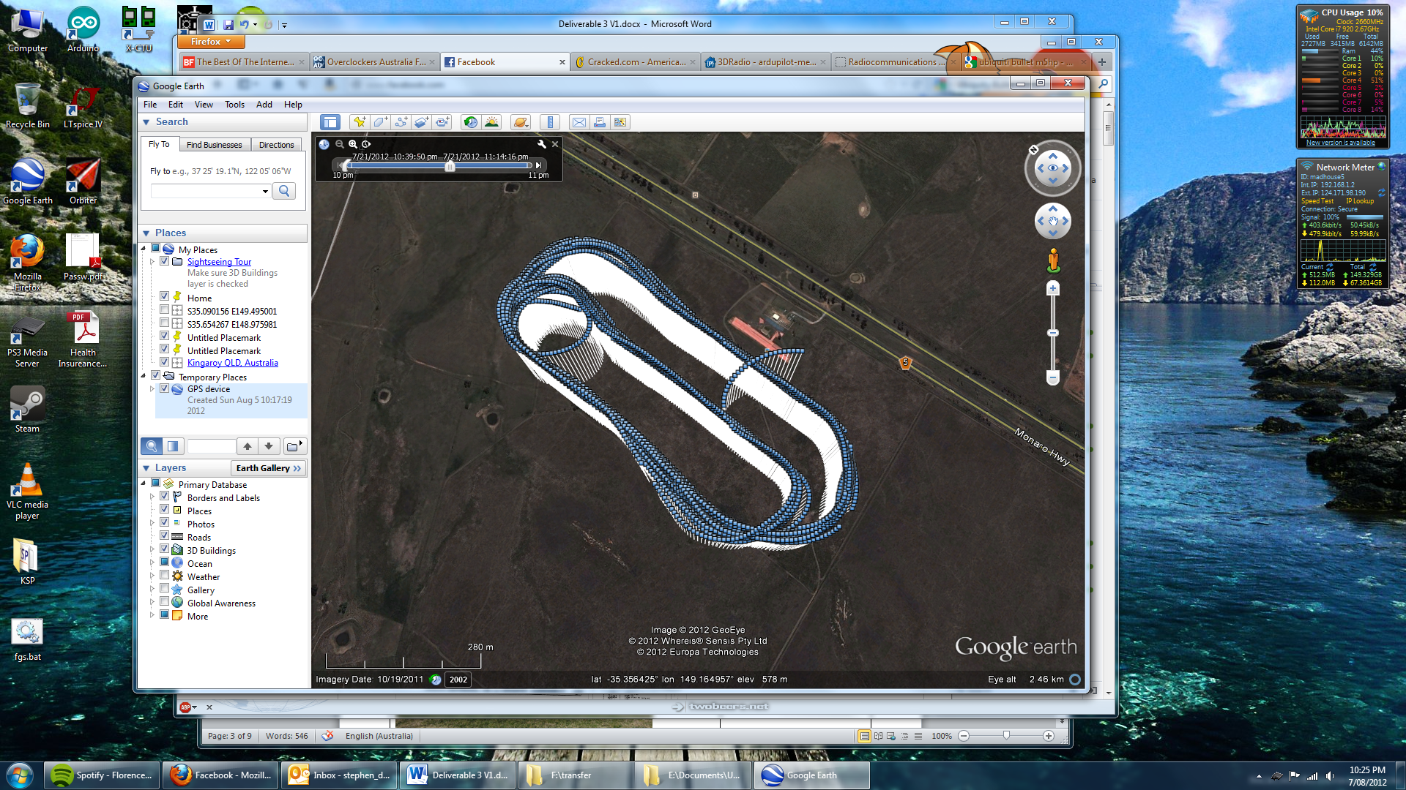

The full file is available from <https://docs.google.com/open?id=0BxJBg_6KSZ5zTmo4NE5Xdm1YUmM>. The file is in kmz format and is able to be opened in Google Earth.

## Video

A video showing the aircraft during autonomous flight and the operational ground station is available at <http://www.youtube.com/watch?v=isY0MPsSQs4>.

## Static Images

The following are a set of static images showing the ground station, aircraft and team members during flight operations from a number of flights over the last 3 months.

|  |  |
| --- | --- |
| E:\Documents\UAV Challenge\uav photos\Michael\CIMG0684.JPG | Pre-flight checks |
| E:\Documents\UAV Challenge\uav photos\19th May 2012\IMG_3499.JPG | Pre-flight checks |
| E:\Documents\UAV Challenge\uav photos\Michael\CIMG0690.JPG | Fuelling the UAV before flight |
| E:\Documents\UAV Challenge\Deliverable 3\photos\IMGP6932.JPG | Starting the engine |
| E:\Documents\UAV Challenge\uav photos\19th May 2012\IMG_3510.JPG | Taxiing to the runway for takeoff |
| E:\Documents\UAV Challenge\uav photos\19th May 2012\IMG_3524.JPG | Starting the takeoff run |
| E:\Documents\UAV Challenge\uav photos\19th May 2012\IMG_3525.JPG | Takeoff |
| E:\Documents\UAV Challenge\uav photos\15th July 2012\IMG_3654.JPG | The Ground Station during flight. |
| E:\Documents\UAV Challenge\uav photos\15th July 2012\IMG_3657.JPG | The Ground Station during flight. |
| E:\Documents\UAV Challenge\uav photos\19th May 2012\IMG_3526.JPG | During automated flight |
| E:\Documents\UAV Challenge\uav photos\Michael\CIMG0698.JPG | Removing the UAV from the runway after landing |

# RF Transmitters

## 2.4 GHz RC Link

This link is used for manual RC control of the UAV’s throttle and flight control surfaces.

|  |  |
| --- | --- |
| Specification | Value |
| Model | FrSky DJT 2.4 GHZ |
| Transmission Frequency | 2400 – 2483.5 MHz |
| Transmitter Power | 60 mW (17 dBm) |
| Transmitter antenna gain | < 5 dBi |
| Calculated EIRP | < 23 dBm |
| Covering licence | Radiocommunications (Low Interference Potential Devices) Class Licence 2000. Part 45A, 53, 54  “C-tick” No. N14939 |

## 900 MHz Telemetry Link

This is a low bandwidth link for transmitting telemetry from the UAV to Ground Station. Commands can be sent from the Ground Station to UAV when necessary. They have been calibrated and tested for LIPD-2000 (Part 52) compliance by RFDesigns RF lab in Brisbane.

|  |  |
| --- | --- |
| Specification | Value |
| Model | RFD900 Telemetry Radio |
| Transmission Frequency | 915 – 928 MHz, 50 Channel Hopping |
| Transmitter Power | 27 dBm |
| Transmitter antenna gain | 3 dBi |
| Calculated EIRP | 30 dBm |
| Covering licence | Radiocommunications (Low Interference Potential Devices) Class Licence 2000. Part 52 |

## 5.8 GHz Image and Telemetry Link

This is a high bandwidth link for transmitting images from the UAV’s on-board cameras to the Ground Station. As a backup, the telemetry and command datastream also uses this link.

|  |  |
| --- | --- |
| Specification | Value |
| Model | Ubiquiti Bullet M5HP |
| Transmission Frequency | 5750 MHz |
| Transmitter Power | 25 dBm (UAV) 16 dBm (Ground) |
| Transmitter antenna gain | 5 dBi (UAV) 20 dBi (Ground) |
| Calculated EIRP | 30 dBm (UAV) 36 dBi (Ground) |
| Covering licence | Radiocommunications (Low Interference Potential Devices) Class Licence 2000. Part 45B, 55  “C-tick” No. N14691 |

# Aircraft Specifications and Performance

The Aircraft platform used by Canberra UAV is a Mugin (donated by CyberTechnology P/L). It has the following specifications:

|  |  |
| --- | --- |
| Specification | Value |
| Maximum Airspeed | 100 kts (180 Km/h) |
| Cruise Airspeed | 50 kts (90 Km/h) |
| Endurance at maximum airspeed | Estimated 30 minutes |
| Endurance at cruise airspeed | 80 minutes |
| Maximum take off weight | 22 Kg |
| Competition take off weight | 18 Kg |
| Wingspan | 3 m |
| Airframe length | 2.5 m |
| Identifying marks | “08WA” on side of fuselage |
| Aircraft planform and configuration | Twin boom V-tail pusher aircraft |